VISVESVARAYA TECHNOLOGICAL UNIVERSITY

BELAGAVI – 590018



Project Report

**Facial Recognition Assisted**

**Attendance Management System Website**



#### Prof. Mohammed Hafeez M K

#### Department of Computer Science & Engineering P.A.College of Engineering

#### Mangalore – 574153

#### 

Submitted by:

Mr. Sayed Nawaf

###### Semester: 6th Sem

#### Department of Computer Science & Engineering

Submission date: 20 June, 2022

**Contents**

Contents Pg. No.

1. Introduction 1
2. Overview of the Project 4
   1. Purpose 4
   2. Objectives 5
   3. System Requirements 6
   4. Key Issues 7
   5. Scope 11
      1. Website Requirements / Deliverables 11
      2. Milestone list 14
      3. Limits and Exclusions 15
3. Screenshots 17
4. References ----------------------------------------------------------------------------------------25
5. Conclusion 26
6. Appendix 2: Member’s Profile 30
7. **Introduction**

With advancement in the AI & ML field in the past decade, its application has enable to solve lot of real world problems. With its ability to achieve a maximum precision of human level accuracy in predictive task like face detection, natural language processing etc has opened a gate of potential implementation that can make real world task completions not only quicker but also efficient.

The massive upgrade for an average mobile device hardware capabilities in past decade alongside with javascript support for tensorflow library with improved stability over the years has capacited performing Deep Learning task in the browser itself resulting in massive boost in performance and less load to server.

In this Project I developed an Attendance management system with facial recognition attendance marker ie Marks attendance upon recognizing a students face. Where the entire facial recognition task is done using javascript in browser, using the capabilities of Tensorflow.js.

The work is done by a single person with a supervisor from faculty member. And no amount of money was used in making of this project.

1. **Overview of the Project**

**2.1 Purpose:**

Motivation behind this project is to reduce the substantial time consumed in manually marking attendance using facial recognition through the Professors phone or laptop and also provide an attractive, efficient and user friendly attendance management system to make a Professors experience less cumbersome.

Marking Attendance manually can result in consuming up to 15 mins of class time, which is a considerable problem as with a jam packed syllabus, time is of the essence. Using my website which is responsive a given teacher can scan the class using his/her mobile phone and upon recognizing all students present in class,it can update attendance for their respective class, which can take up to to maximum 3 mins,since the facial recognition system not only recognizes face in seconds but also supports multiple face recognition at a time.

The main purpose of this website is to utilize the capabilities of Tensorflow.js which provides Deep Learning predictive modelling in browser itself without the need of any processing in the server reducing latency and load to server to substantially reduce attendance marking time and effort through facial recognition also provide an attractive, user friendly and efficient attendance management system.

All activities related to the purpose are considered to be in scope. All activities not directly related to the purpose are considered to be out of scope.

**2.2 Working:**

Facial Recognition task is done using face-api.js a **JavaScript API for face detection and face recognition in the browser implemented on top of the tensorflow.js core API**.

Its Face detection Feature works by generating a facial embedding which is as array of 128 dimension that uniquely identifies a face upon inputting a user picture.so its detects a face by comparing its face embeddings with all the registered face embedding using Euclidean distance.to prevent it from mapping an unknown face with the closest embedding a threshold on how close the embedding should be to qualify as the same person is provided. Threshold of 0.6 has been found to do be really accurate.

But before performing face embedding mapping with the registered faces following task has to be performed.

Simply put, we will first locate all the faces in the input image**.**Face-api.js implements multiple face detectors for different use cases.

The most accurate face detector is a **SSD** (Single Shot Multibox Detector), which is basically a **CNN**based on **MobileNet V1**, with some additional box prediction layers stacked on top of the network.

Furth more, face-api.js implements an optimized **Tiny Face Detector**, basically an even tinier version of Tiny Yolo v2 utilizing depthwise seperable convolutions instead of regular convolutions, which is a much faster, but slightly less accurate face detector compared to SSD MobileNet V1.

The networks return the **bounding boxes** of each face, with their corresponding **scores**, e.g. the probability of each bounding box showing a face. The scores are used to filter the bounding boxes, as it might be that an image does not contain any face at all. Note, that face detection should also be performed even if there is only one person in order to retrieve the bounding box.

Its important to **align**the bounding boxes, such that we can extract the images centered at the face for each box before passing them to the face recognition network, as this will make face recognition much more accurate!

For that purpose face-api.js implements a simple CNN, which returns the **68 point face landmarks** of a given face image:

From the landmark positions, the bounding box can be cantered on the face.

Now we can feed the extracted and aligned face images into the face recognition network, which is based on a **ResNet-34** like architecture.

The network has been trained to learn to map the characteristics of a human face to a **face descriptor** (a feature vector with 128 values), which is also oftentimes referred to as face embeddings.

**2.2 Objectives**

The objectives of the project are given below:

* + 1. Receive student Photos through admin page, generate face encoding and store in mysql database with respective usn.
    2. Integrate Face-api.js in the website .
    3. Create Video element in HTML that reads each frame of camera feed and pass’s to a javascript function that generates the face embedding .
    4. Load all the face embeddings of students from the mysql database and compare the input facial embedding through webcam with the loaded face embedding form database and find match.
    5. Update attendance of matched students.
    6. Create a Dashboard that displays attendance taken, Total attendance percentage, month wise and sem wise and if a student was present or absent in resent class.
    7. Create a attendance Report table that displays the attendance status over a range of selected date if attendance not taken on a given date display not taken and also support ability to mark attendance using the table.
    8. Create a table that enables a professor to mark attendance manually for a specific date
    9. A login system that authenticates if user is an authorized professor with password given by the admin which maps it to the professor id which intern maps to the subjects taken by the professor and upon logging with respective pass allows user to only take attendance for their respective subject

**2.3 System Requirements**

SOFTWARE REQUIREMENTS:

* Operating system- Windows 10 is used as the operating system as it is stable and supports more features and is more user friendly.
* Database MYSQL-MYSQL is used as database as it is easy to maintain and retrieve records by simple queries which are in English language which are easy to understand and easy to understand and easy to write.
* Computer with a minimum of 4 gb RAM and intel i3 processor or more.
* Ubuntu is also supported.
* XAMMP server is used as the localhost for hosting/running the website.

**2.4 Key Issues**

The project is on a tight schedule with just under a month to make it up and running. So utilizing the time is key in this case for getting things done.it also uses a database to store user credentials of the user so it is important to maintain the database or to start the sql server in xammp app.

Rare cases the website may map an unregistered person to its closest registered person.

**2.5 Scope**

The project will cover the following deliverables and any other approved web design elements and website functionalities as per required by the User and backend systems as per Technologies Ltd.

* + 1. **Website Requirements / Deliverables**

##### Website Contents

* + - * 1. Login page which allows the Professor to login into the website.
        2. Admin page where a student facial embedding can be registered and Professor subject permission can be allotted.
        3. Manual Marker page where Professor can manually assign attendance.
        4. Facial recognition page where Professor can assign attendance through facial attendance.
        5. Dashboard page which displays attendance details.

##### Details user’s manual on using and maintain the website

* + - * 1. Keep updating the subject and new professor subjects every time changes are made sem in the database.
        2. Check for variance in input from webcam to verify change in camera software.
        3. Check for variance in Matching accuracy to verify if embedding generation process of library has changed.
        4. Check for the right threshold value over period of time.

##### Web Design Elements

The website hosts a user-friendly and attractive user interface with a nav bar which is consistent across different pages.

##### Website Features

* + - * 1. Enhance user experience

It has a good user interface which is easy to use and pleasing for the eye too. With features like horizontally scrollable tables interactive attendance buttons and dropdowns for selecting subject and periods.

* + - * 1. Admin page

Allows to register Student embedding and assign subject permission to professor. Requires only one photo for registering face embedding.

* + - * 1. Login Page

The registered Professor can login in to the website using the registered credentials.

* + - * 1. Account access

Only the registered user can access the website and the user can logout at any time.

* + - * 1. Security for online registration

Registrations ,documents etc. are protected from malicious and fraud attacks.

* + - * 1. Dashboard

It calculates the overall attendance of student sem wise also month wise and displays it

* + - * 1. Top nav bar

It also has a top navigation bar which consists of navigation to different pages and a logout button to allow the user to logout of the website after a session.

* + - * 1. Attendance Button

Buttons generated in attendance table where user can click to change to opposite attendance status to change to respective attendance status color and text which is reflected in database.if no attendance is taken on the selected date then button generated in grey with text not taken

* + 1. **Milestone list**

|  |  |  |
| --- | --- | --- |
| **Milestone** | **Description** | **Day** |
| **Website Design approved** | Graphical design for the website completed and can be used. |  |
| **Account and login** | Accounts and login system is done. |  |
| **Phase 1 - Presentation** |  |  |
| **Main Site Completed** |  |  |
| **Completed** |  |  |
| **Draft Report** |  |  |
| **Phase – 2 Presentation** |  |  |
| **Corrections incorporated & Final Report Submission** |  |  |

* + 1. **Limits and Exclusions**

No provision to assign attendance by entering the usn and filtering.

Facial Recognition though promises up to 90% accuracy but not 100%.

Not included an automated way to register students encoding through an excel sheet only way is manual registration.

Professor can assign attendance only up to 4 periods per day per subject

**8** Screenshots

**8.1** **Full Process Breakdown Structure**

**Login:**

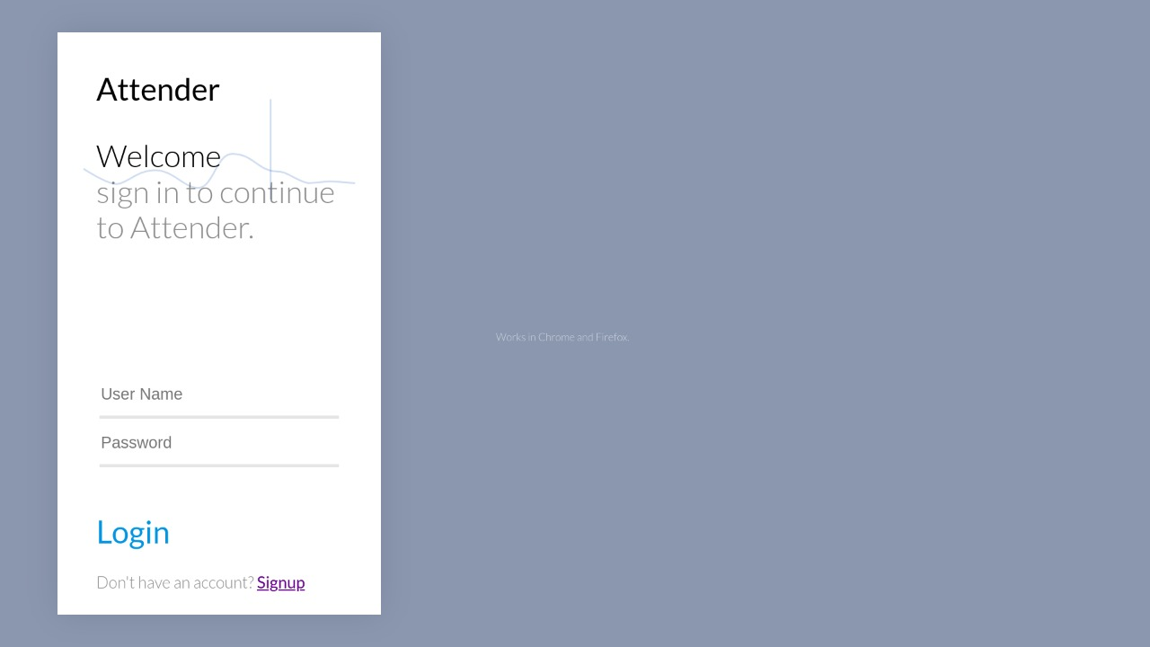

**Admin:**

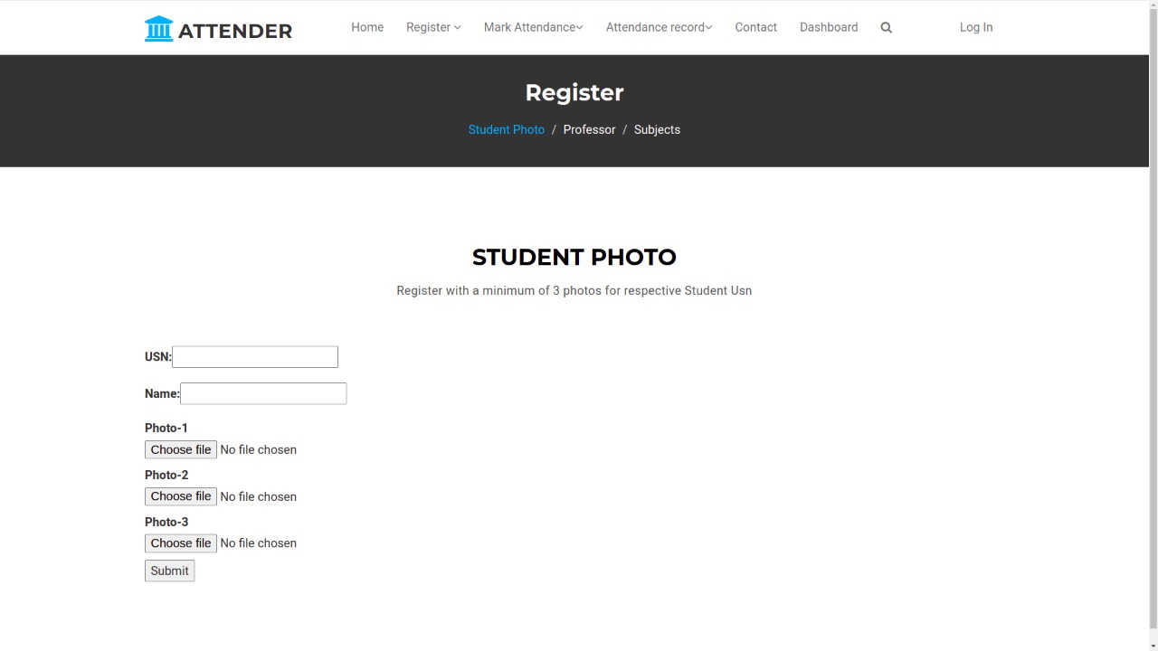

**Home page:**

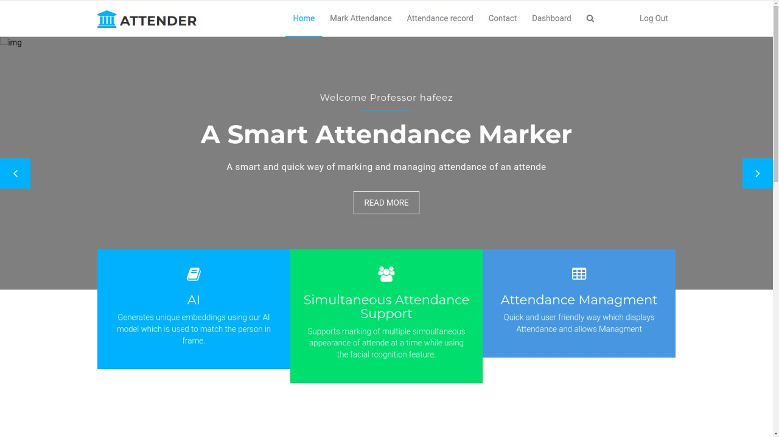

**Dashboard Page:**

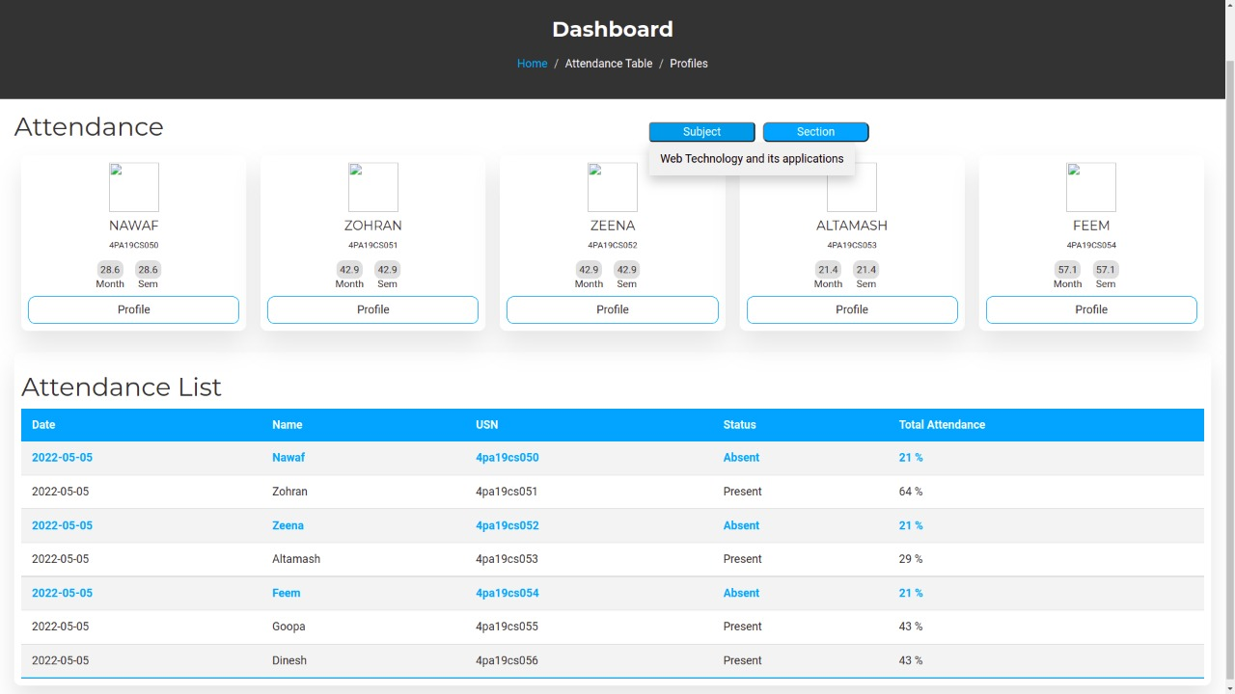

**Attendance Report and Marking Page:**

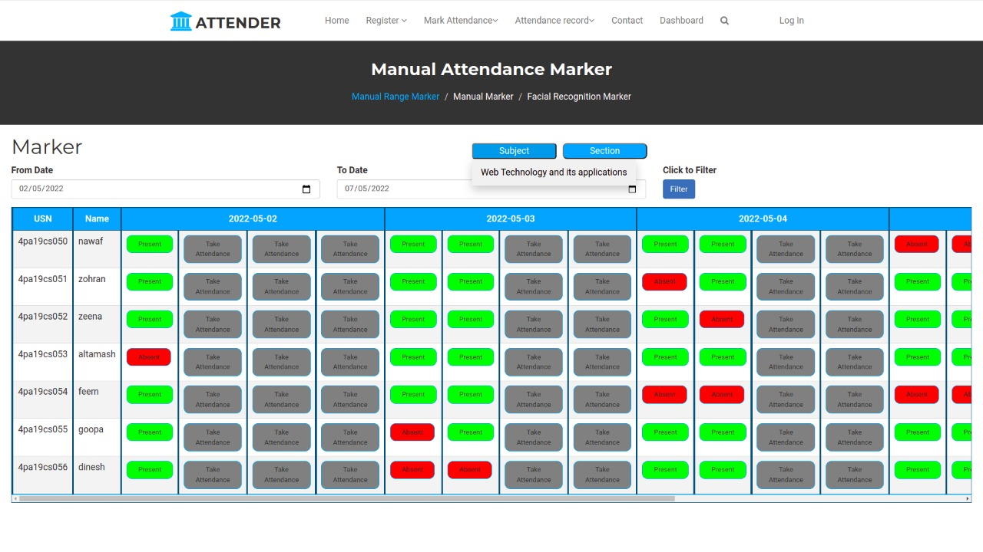

**Individual Date Marking Page:**

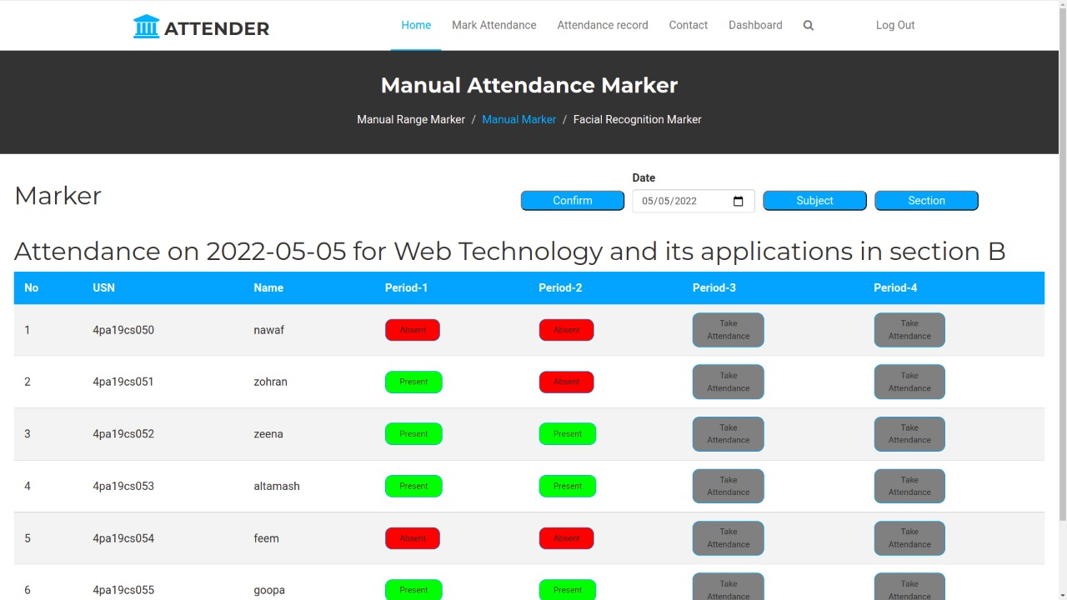

**Facial Recognition Marking Page:**

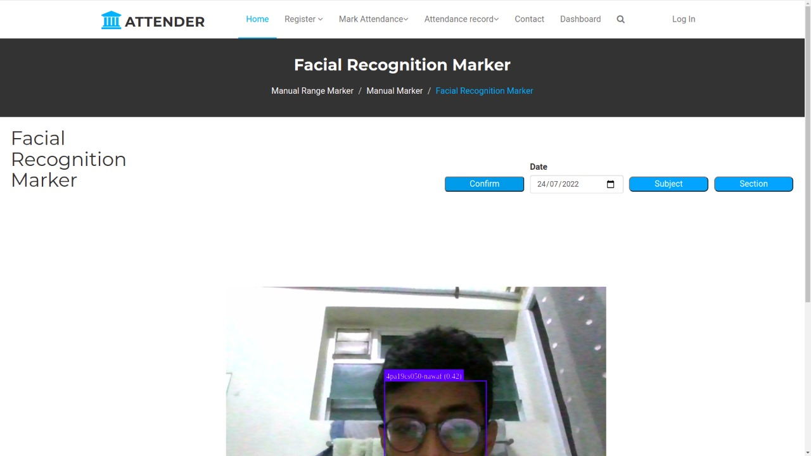

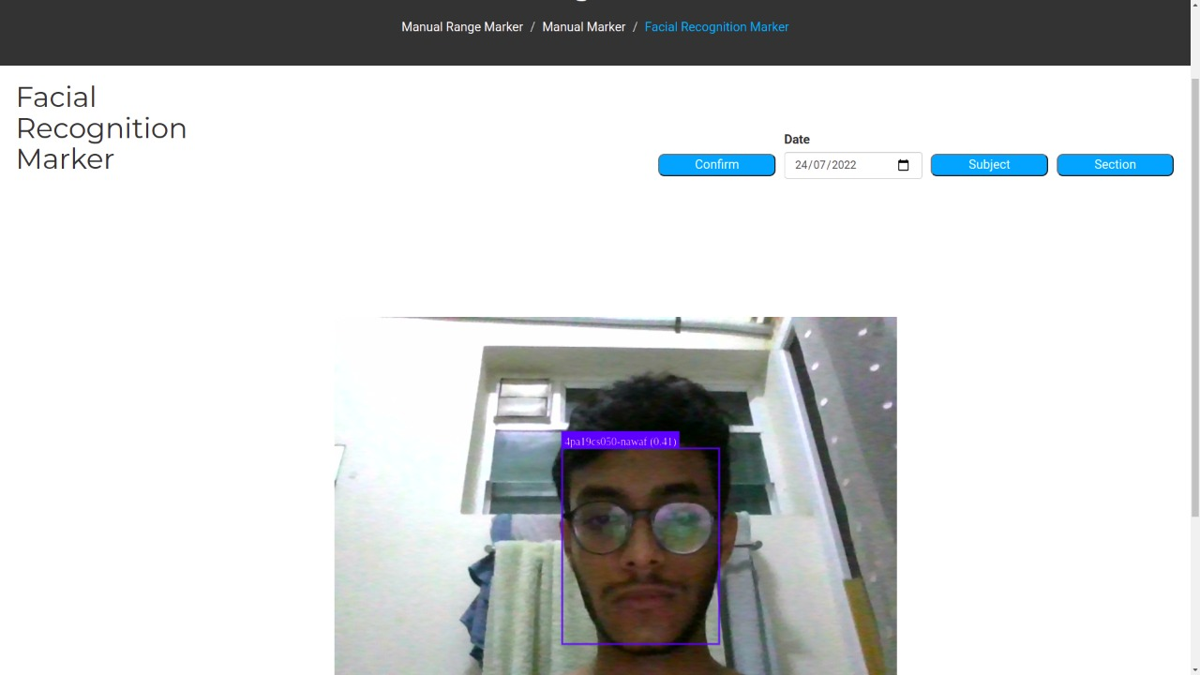

**References:**

https://www.w3schools.com/css/default.asp

https://www.w3schools.com/js/default.asp

https://www.w3schools.com/html/default.asp

1. **Conclusion**

This project is a dedicated venture to help reduce the amount of time and effort to mark attendance manually utilizing the prowess of AI. Several user friendly coding steps have also been adopted. This package shall prove to be a powerful package in satisfying all the requirements of the organization. The objective of software planning is to provide a frame work that enables the manager to make reasonable estimates made within a limited time frame at the beginning of the software project and should be updated regularly as the project progresses. This website provides a computerized version of my way to use AI to solve a problem my professor encounter on a daily basis. The website also focus’s on providing an easy and eye pleasing interface to make the experience of professors less cumbersome. The website can be edited whenever required to add new attendance management and dashboard features. Without much hassle.

1. **Appendix 1: Assumptions**
2. **Appendix 2: Member’s Profile**
   1. **Project Manager, Graphics Designer & Web designer**

**Mr. SAYED NAWAF**

P.A College of Engineering mangalore. 

*Email: 4pa19cs087@pace.edu.in*

*Mobile:* **+919567791420**

**Bachelor of Engineering**

*University* : P.A college of engineering mangalore

*Branch* : Computer science and Engineering

Passing Year 2023



* + 1. Evaluation of Project Benefits
    2. Performance Evaluation

The performance of the project (timeliness, accuracy, efficiency, effectiveness etc.) should be evaluated and state any suggestions.

* + 1. Summary of Issues

Check issues arose during the project period and comment on them

* + 1. Lessons Learned

What new experience? In case of negative experience what would be the action to avoid these in next time?